DIAGNOSTIC ANALYSIS OF HEALTHCARE OPERATIONS: AN ANALYTICAL REPORT

A project report submitted for CPSC-600-10
Advanced Data Visualization
Master of Data Analytics program

Mihir Ashokkumar Mistry

Table of Contents

1. Introduction 3
2. Data Model and Data Preparation Decisions 3
3. Operational Efficiency Analysis 4
4. Patient Outcome and Chronic Condition Analysis 5
5. Regional Service Analysis 6
6. Anomaly Detection and Benchmark Analysis 6
7. Key Findings and Explanation of Patterns 7
8. Limitations 8
9. Recommendations 8
10.Conclusion 9
11. AI Tool Use Disclosure 9

1. Introduction
The aim of this project is to conduct a diagnostic analysis of the operations in the healthcare industry based on patients and visit data from the healthcare dataset. The analysis was made with the aim of highlighting inefficiencies in the operation, analyzing the service delivery pattern, evaluating the patient outcomes, studying the regional variations and isolating the odd operational behaviors. Diagnostic analysis is different from descriptive analysis, where the goal is to describe the observed pattern, as its purpose is to explain why the observed patterns might exist, using the available evidence.
Tableau Prep Builder and Tableau Desktop have been used to complete the project. A multi-dashboard analytical solution was created that can provide an executive-level overview as well as detailed operational information. The dashboards were built in an “Overview → Diagnosis” format and users were able to then drill down into the performance of the operations at departmental, patient group, regional and service outcome level.
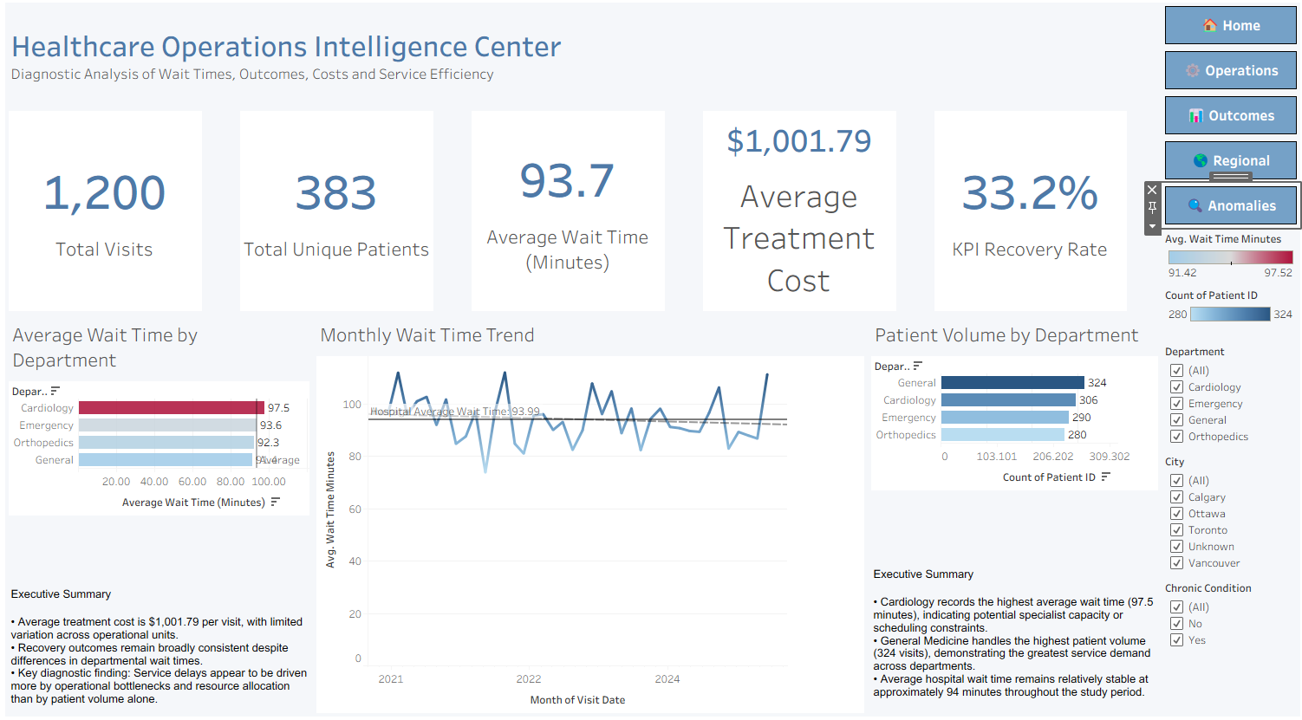
Figure 1: Healthcare Operations Intelligence Center Dashboard

2. Data Model and Data Preparation Decisions
There were two tables in the dataset, namely Patients and Visits.
Patient-level information, such as Patient ID, Age, Gender, City, and Chronic Condition status were present in the Patients table. The Visits table included Visit-level information such as Visit ID, Patient ID, Visit Date, Department, Wait Time Minutes, Treatment Cost, and Outcome.
Patient_ID was used for a one-to-many relationship since a patient may have many visits to the healthcare system. This relationship helped to ensure that the patient-level attributes would not be duplicated, and the level of granularity was maintained.
Several decisions were made about the data preparation:
The use of Patient_ID as the primary field for integration between datasets was employed.
- City missing values were not eliminated but rather categorized as ‘Unknown' to ensure that data quality issues would not be concealed during analysis.
- Wait Time values were not replaced with a value of zero; this would create artificial observations.
- Other analysis fields have been added such as Wait Category, Patient Type, Cost Category, Outcome Score, Visit Month and Wait Time Quality.
These preparations helped to minimize aggregation errors and included making sure that operational metrics reflect healthcare activity.

3. Operational Efficiency Analysis
The Operational Efficiency Dashboard was created to explore departmental performance, service demand and wait times behavior.
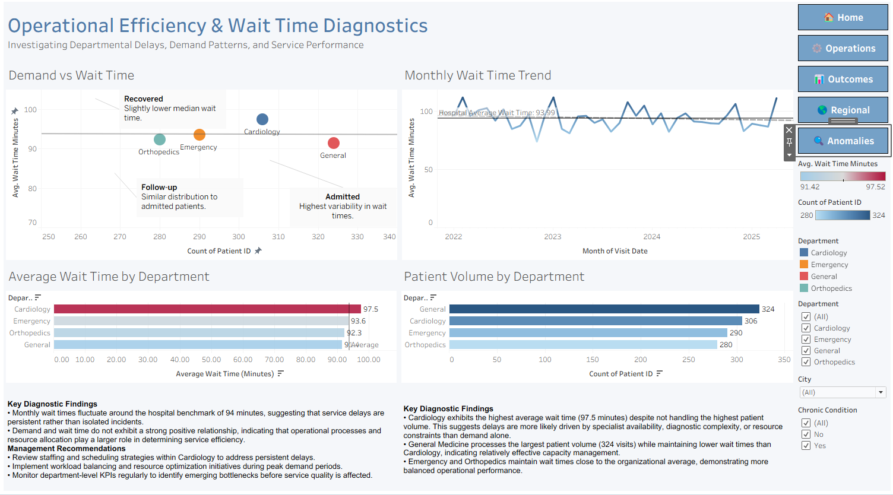
Figure 2: Operational Efficiency and Wait Time Diagnostics Dashboard
The Operations Dashboard screen shot is shown in Figure 2.The Operations Dashboard screen shot is illustrated in Figure 2.
Compared with the hospital-wide average wait time of around 93.7 minutes, the analysis found that Cardiology had the longest average wait time (97.5 minutes). Cardiology, however, was not the top department for patients. General Medicine had about 324 visits processed, and had the shortest waiting times of all departments, except for Cardiology.
This discovery means that the volume of patients isn't the only cause of departmental delays. In the event that service demand is the most important factor in delays, General Medicine should be the slowest service. Rather, The dashboard evidence suggests that patient volume alone does not explain the higher wait times observed in Cardiology. Additional factors influencing performance cannot be determined from the available dataset.
Monthly wait-time trend also showed that wait-time remained relatively stable throughout the analysis period. Wait times varied from the organizational benchmark, and were not consistently improving. This indicates that service delays can be a result of the continued operational conditions, and not just a one-off occurrence.

4. Patient Outcome and Chronic Condition Analysis
The Patient Outcome Dashboard was created to explore connections between wait times, patient outcomes, chronic conditions and treatment costs.
The figure below is a screen shot of the outcome dashboard. Below is the screen shot of the outcome dashboard.
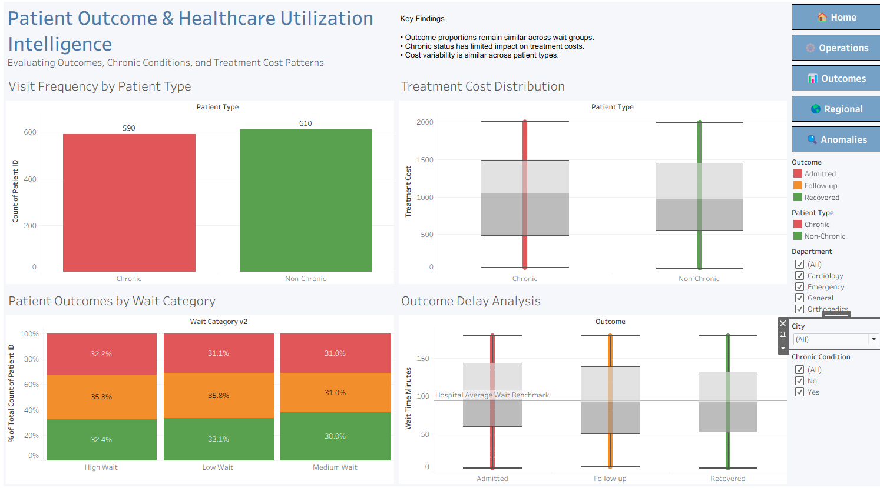
Figure 3: Patient Outcome and Healthcare Utilization Intelligence Dashboard
When outcomes were analyzed, the numbers of recovered, admitted and follow-up patients were fairly evenly split between the low, medium and high wait-time groups. No evidence was found on the dashboard that there was any significant difference in the distribution of outcomes based on the duration of the wait.
This does not mean that a wait time is not important. Instead, it indicates that other clinical factors not recorded in this data set may be affecting the outcome of a patient in this data set.
Additionally, the analysis looked at the status of chronic conditions. The number of visits made by chronic patients was about 590 and by non-chronic patients was about 610. Additionally, distributions of treatment costs were generally comparable between the two patient groups.
Available data do not seem to indicate that chronic condition status is a large driver of variation in the use of healthcare services or treatment costs. Other factors are also important with regard to operational workload – including the type of department and the complexity of treatment.

5. Regional Service Analysis
Geographic disparities in waiting time and cost of treatment were studied using the Regional Intelligence Dashboard.
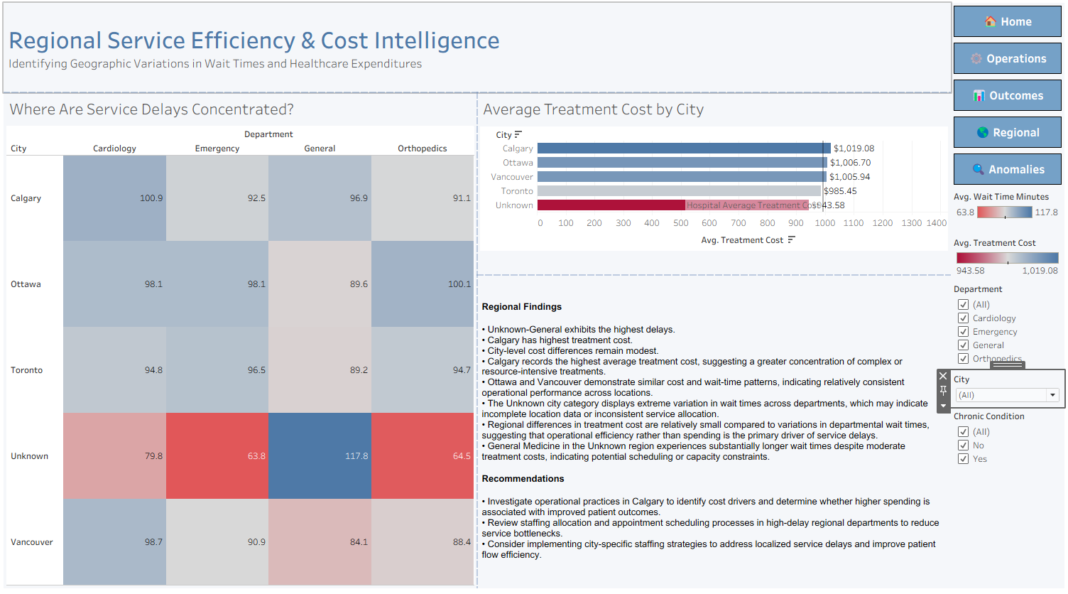
Figure 4: Regional Service Efficiency and Cost Intelligence Dashboard
Calgary had the highest cost for treatment at an average of about $1,019 per visit. Nevertheless, the costs of treatment in different cities were almost equal.
The more valuable picture was shown by the city-department heat map. The Unknown City combined with General Medicine had the longest waiting time at an average of around 117.8 minutes.
As the Unknown category refers to lack of geographic data and not real regions, this result should not be regarded as a matter of regional performance. This indicates possible problems with the data quality as well as need to examine patients' records with missing demographic characteristics.
In conclusion, it can be stated that the geographic performance of departments is relatively homogeneous whereas departmental performance is rather heterogeneous.

6. Anomaly Detection and Benchmark Analysis
Anomaly Detection Dashboard was intended to detect anomalous operations based on wait times and treatment costs by comparing departments with each other.
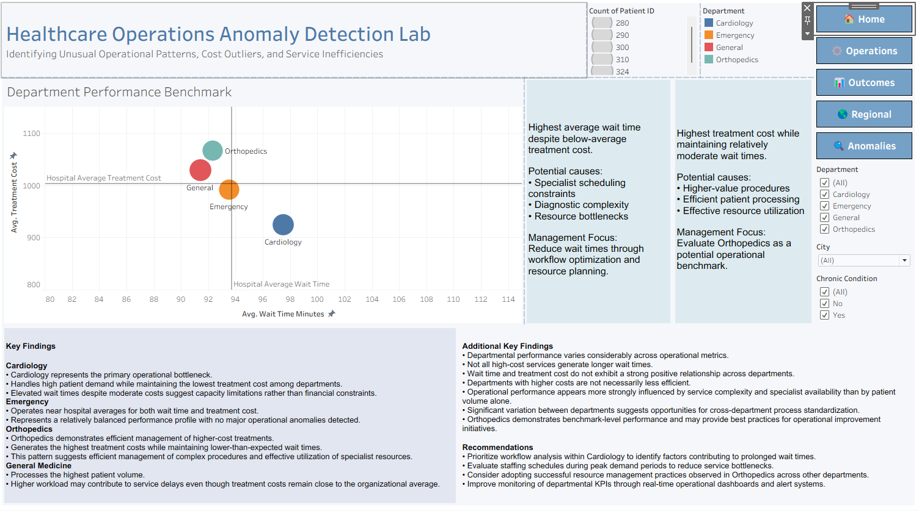
Figure 5: Healthcare Operations Anomaly Detection Dashboard
Here are two anomalous patterns found.
On the one hand, Cardiology had the highest wait time but at the same time neither the highest volume of patients nor the highest costs for treatment. Therefore, cardiology recorded the highest average wait time despite not having the highest patient volume or treatment cost. This indicates that factors beyond volume and cost may influence departmental performance.
On the other hand, Orthopedics had high costs for treatment but the wait times for them were lower than the organizational average. Consequently, increased treatment costs do not automatically translate into low efficiency.
Thus, healthcare should be assessed about several criteria simultaneously rather than solely in terms of treatment cost or volume of patients.

7. Key Findings and Explanation of Patterns
Finding 1 – Higher Utilization of Healthcare Services
A higher level of healthcare utilization was found. In total, there were 1,200 visits for just 383 unique patients, implying that multiple visits had been necessary. This finding implies that operationally, workload is not determined solely by the number of patients seen but rather by the volume of visits required. Consequently, resource management needs to be focused on visits and not just patient visits.
Finding 2 – Cardiology Encounters Longest Average Wait Time
In the analyzed department, the longest average wait time (approximately 97.5 minutes) occurred at Cardiology Department compared to the average wait time (approximately 93.7 minutes) in the entire hospital. However, it should be noted that Cardiology was not the highest-volume department. Approximately 324 visits occurred in General Medicine; however, wait times there were lower.

Finding 3 – Stable Monthly Wait-Time Trends
It can be seen from the data analysis that the monthly wait-time trends were stable throughout the period under analysis. They fluctuated slightly around the benchmark; however, any improvements were not evident from the results.
Finding 4 – Stability of Outcome Distribution Depending on Wait Category
Similar proportions of patients had either a recovered, an admission case, or a follow-up one irrespective of their wait times. Thus, based on the obtained information, no significant correlations exist between patient outcome distribution and wait-time category.
Finding 5 – The Status of Being a Chronic Patient Does Not Determine Healthcare Utilization
There were approximately 590 visits to patients with chronic diseases compared to approximately 610 visits to patients with no chronic diseases. Similarly, the treatment costs distribution in both subgroups were almost identical. It means that being a chronic patient did not play a vital role in the analysis of treatment costs and healthcare utilization.
Finding 6 – The Impact of Location on Treatment Costs Is Minimal
The city with the highest treatment costs was Calgary with an average treatment cost of about $1,019 per patient visit. This implies that the differences in treatment costs were not significantly influenced by the location.
Finding 7 – Possible Data Quality Issue Observed Through Regional Analysis
The combination of Unknown City and General Medicine resulted in the highest wait time at about 117.8 minutes. Given that Unknown is used to refer to cases where the city could not be specified, this may indicate a possible problem with data quality.
Finding 8 – Departments with Significant Performance Differentials
In the departments' performance, Cardiology had the highest average wait times yet was neither one of the busiest departments nor one of the most expensive. On the other hand, Orthopedics was among the departments with the lowest wait times yet one of the most expensive.

8. Limitations
Several limitations must be noted.
The analysis involved observational health care data; hence, no causation can be established. The dashboards only show trends and associations but cannot prove the causative factors behind these trends.
Furthermore, missing values in attributes such as City and Wait Time Minutes might affect some of the analyses carried out. Thirdly, important clinical attributes which would impact on the results were not included in the data set.

9. Recommendations
- Conduct a workflow review within the Cardiology department to investigate factors associated with above-average wait times and identify opportunities for operational improvement.
- Establish department-level performance benchmarks in addition to hospital-wide averages to improve operational monitoring.
- Implement regular dashboard monitoring of wait times, patient volume, treatment costs, and outcomes to support evidence-based decision-making.
- Improve data quality controls for demographic information, particularly City records, to strengthen regional analysis reliability.
- Perform periodic reviews of staffing and resource allocation during peak service periods to identify potential operational bottlenecks.
These recommendations are supported by the dashboard evidence without claiming causes that the dataset cannot prove.

10.Conclusion
In this regard, the project succeeded in implementing the integrated healthcare analytics system that can facilitate decision making based on diagnostic visualizations.
The findings revealed that the performance of healthcare delivery involves numerous interrelated parameters, such as departmental procedures, patient demand, treatment difficulty, and operational efficiency. The integration of reporting, diagnostics, outcomes analysis, regional intelligence, and anomalies detection allows creating a holistic approach to evidence-based healthcare management.

11. AI Tool Use Disclosure
The analysis was done using the healthcare operations data provided and the dashboard generated through Tableau. Although the dashboard is able to detect the operational trends and even suggest reasons, it does not provide any concrete evidence on causes. For instance, from the Tableau Dashboard, it can be seen that Cardiology recorded the highest average wait time, yet more information would be required to conclusively determine the cause. The presence of missing values for City and Wait Time Minutes is another factor that constrains the interpretations made using this dashboard.
No AI technology was applied in completing this assignment. The preparation of data, modeling of data using Tableau, designing the dashboard, visual analysis, interpretations, recommendation, and writing of this report were carried out independently of any generative AI technologies.

